Please see below associated fees for your Planning Proposal Application.

Property Strathvale Road, Berrigan

 |  | GST | QUICK CODE
Planning Proposal Fee | $760.00 | Free | 103
TOTAL | $760.00

Payment Details:

EFT: reference: BuildPlan (applicant name)
BSB No. 633-000 Account No. 162899652
VISA / MasterCard – phone with details

Furthermore applications will not be processed until fees have been received.

If you require further assistance, or to make payment, please do not hesitate to contact me on 03 5888 5100.

Kind Regards,

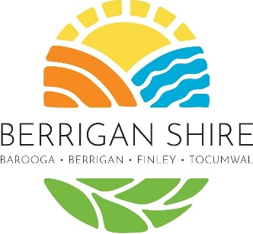 | Kelly Milich  Administration Support - Building & Planning  Berrigan Shire Council | 56 Chanter Street, Berrigan NSW 2712  P: 03 5888 5100  E: Kellym@berriganshire.nsw.gov.au  W: www.berriganshire.nsw.gov.au

